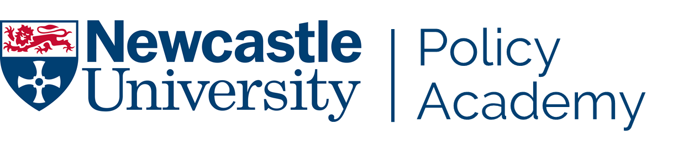
APPLICATION FORM
Please complete the form below providing information to apply for the Policy Academy Fellows Programme 2022.
The Programme supports early to mid-career researchers, teaching staff, professional services staff and postgraduates from across the University who are keen to develop their own toolkits on how their work in the University might inform policy. Further information about the programme is attached to this form.
Please feel free to use bullet points rather than narrative if you wish.

Name |  | Position
Academic Unit/  PS Unit/  Institute/  Faculty |  | Subject/  Area
Telephone No: |  | E-mail  Address
APPLICATION CRITERIA

Priority will be given to those applicants who show clear interest and enthusiasm for the programme and whose work/research could potentially influence a policy need. The application process is intended to ensure that a well-balanced group with varied policy interests is established. We are particularly keen to see an equal gender balance on the programme with representation from the Faculties and Professional Services (PS). We are aiming to secure 20 participants, nominally 5 per Faculty and 5 from PS.

It is a requirement of the programme that participants commit to attending all the sessions. There are a number of reasons for this, including elements of the programme building on previous sessions and understanding broad policy contexts through interaction with colleagues across disciplines (which does not work as well when attendance is intermittent). For this reason, Heads of Unit are also asked to ensure that nominated individuals are able to attend all sessions, including those where it may be necessary to re-arrange or cover other commitments. The time commitment is likely to be 9 days of activity. Please note, all costs associated with the delivery of the course will be covered but there is no resource for back-filling posts when participants are attending courses.

In addition to attendance at all session days, participants should allow some time for collaboration and reflection with programme colleagues.

1. Goals & Objectives
What do you hope to gain, personally and professionally, through participating in the Policy Academy Fellows Programme? Indicate policy areas you are interested in and suggestions for the type of knowledge and experience you would like to develop in the policy context.

2. Policy Relevant Experience
Please briefly outline your career history to date and aspirations for the future. Please include any policy-related activities you have undertaken and those you wish to pursue.

3. Head of Unit/Service Statement of Support
Statement supporting application, comments from Head of Unit.
(As it is a requirement of the programme that participants attend all sessions, we ask that Heads of Unit support nominated individuals in making space for this participation in their workload allocation. This may mean rearranging, rescheduling, or arranging cover for responsibilities as relevant.)

Head of Unit signature: _______________________________ Date: ____/_____/_____

PRINT NAME: _______________________________________

Thank you for completing the form.
Please forward your application form to nu.policyacademy@ncl.ac.uk by Friday 27th August 2021.
If you would like further information or have queries about the Fellows Programme please get in touch:

DRAFT PROGRAMME CONTENT & DATES *

Introductory Session (½ Day) – Wednesday 12th January 2022
A chance to meet fellow participants, Pro-Vice-Chancellor, Engagement & Place, Professor Jane Robinson, Academic Co-Director of the Policy Academy and Academy Alumni. To start to build supportive working relationships and further develop learning objectives for the programme.

Understanding the Policy Environment – Wednesday 26th January 2022
During this session participants will gain an overview of policymaking institutions, individuals, and the environment they work in; hearing from speakers who have helped shape policy from inside and outside of Government. They will build on their understanding of the value that academics bring to policymaking and the routes they have to do so – as well as ways in which the ideal of evidence-led policymaking are sometimes met by complex reality. Participants will also have the opportunity to share their own experiences and continue to build relationships with other participants.

Research to Policy Journey – Wednesday 23rd February 2022
This session will explore the routes research from varying disciplines might take to inform policy. The session will be mainly case-study based and highlight the different methods used, plus it will develop a deeper understanding around timelines for influence.

Understanding where Policy is Developed – Wednesday 23rd March 2022
This session will explore the Civil Service; the work of a Chief Scientific Adviser and the inner workings of a Government Department. In an era of ‘open government’ it will showcase ways in which staff can gain a ‘foot in the door’ and will consider who we need to influence and the nature of relationship building.

Understanding Local Government – Wednesday 27th April 2022
This session will explore where there are opportunities to engage with local Government and to understand the organisations which promote the region. To influence and identify methodologies for engaging with localised policy agendas and the partners who work around them.

Devolution of Powers – Wednesday 25th May 2022
Understanding the roles of the Scottish Parliament, Northern Ireland and Welsh Assemblies; their corporate governance; history of their devolution and their daily business and how to engage with them.

Policy and our Global Reach – Wednesday 22nd June 2022
Discover more about our Internationalisation Strategy and how policy plays a part in our vision to enhance our global reputation for academic excellence.

Writing for Policymakers, Press and Social Media – Wednesday 13th July 2022
Crafting effective content for a range of policy contexts and using the right channels to promote it are skills that requires development of specific techniques. This session will outline principles to apply to a range of policy-related writing, including briefing notes, evidence submissions and comment articles for the press. Participants will explore case study material to identify good practice.

Final Reflections and Celebratory Lunch (½ Day) – Wednesday 21st September 2022
In this final session of the programme, participants will have the opportunity to reflect creatively on their individual and collective challenges and achievements over the course of the programme, to review the learning from the whole programme and develop plans to ensure it continues to be implemented and built upon. We are particularly keen to secure feedback on what worked and didn’t work to shape future programmes.

*dates are tentative at this point and subject to change.

